Computing Report 1 MACM 316 Bhakti Bhanushali

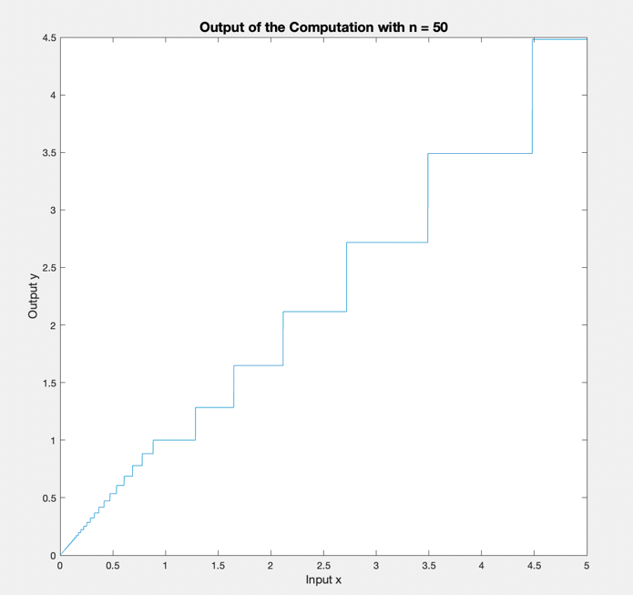

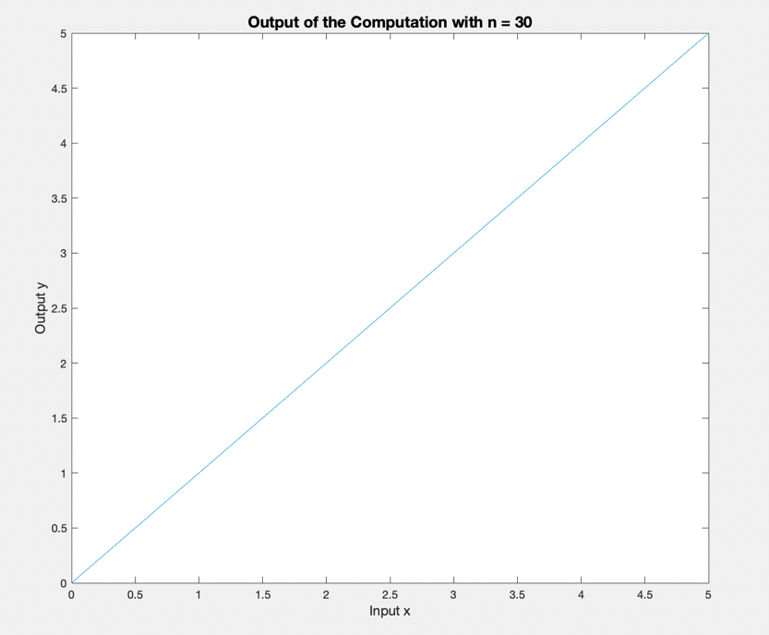a)

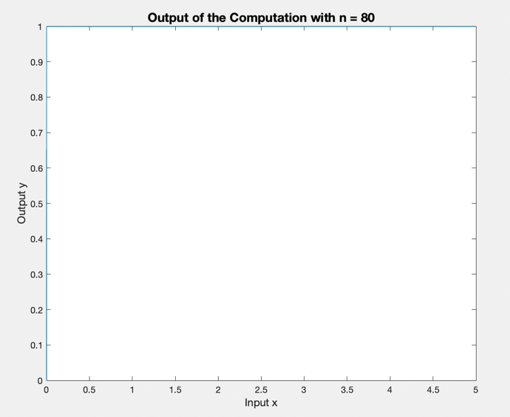

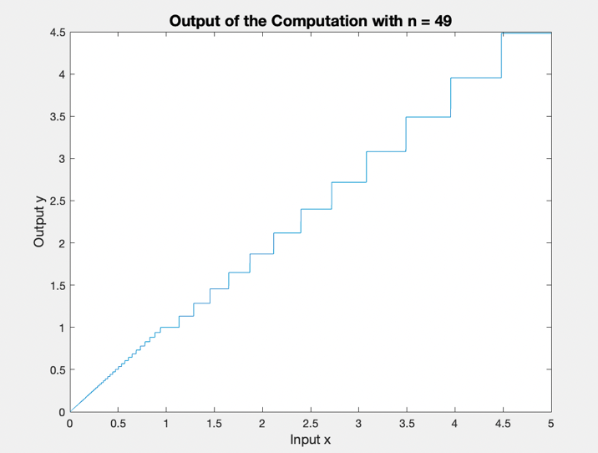

b) It can be observed from the code output that if the values are rounded to 3 decimal places the output starts differing when n = 39. Accumulation of round off errors causes the errors to become larger when n increases. Since we have rounded off to 3 decimal places the error occurs at 39 but if we had rounded off to say 5 or 6 decimal places we would’ve seen the error much earlier.

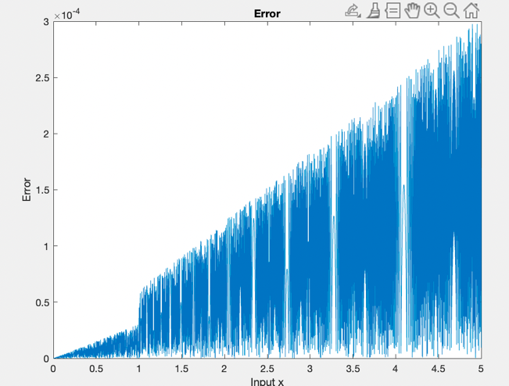

c)

The rounding error increases as the value of x and n increases (as observed from the plot a. When n is significantly large (eg: 80), repeated square rooting of x results in the output being approximately 1. This can be proved by solving = = 1.

d) As n increases the deviation from the true output increases. This happens because of error amplification and accumulation. Error is amplified because of repeated square rooting of small numbers and error accumulation occurs as the number of repeated calculation increases proportionally with n.